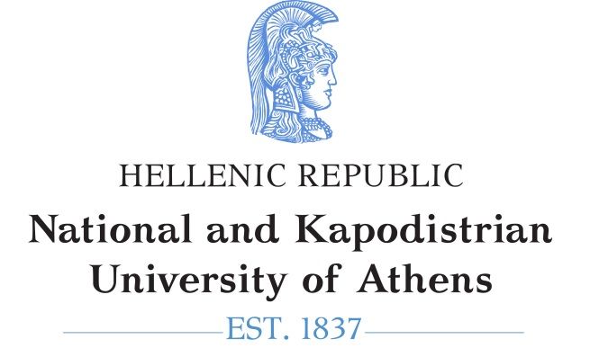 | 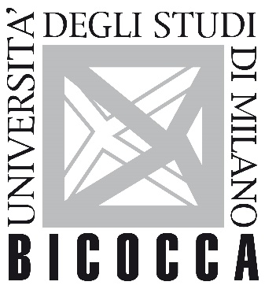

School of Medicine of National and Kapodistrian University of Athens
School of Medicine and Surgery (Dipartimento di Medicina e Chirurgia) of University of Milano−Bicocca

Postgraduate Cooperation Programme

"Endovascular Techniques"

LETTER OF RECOMMENDATION

Name of candidate

MSc applied for

To the assessor:
The submitted application for postgraduate studies in the Postgraduate Cooperation Programme must be accompanied by evaluations from two Professors or Researchers who are in a position to objectively evaluate the academic/professional skills and the prospects of the candidate.

Name of assessor:

Title:

Institute/Company:

Address:

Tel.:

Email:

In the space available for evaluation on page 2, please explain clearly the reasons why you believe the candidate is suitable for postgraduate studies in the Postgraduate Cooperation Programme on ENDOVASCULAR TECHNIQUES. Information on their performance in independent projects or research and their ability to work well with others would be very useful.

Comparison of candidate to their peers as to their academic skills:

- Rare skills
- Among the top of the class
- Among the top 25%

- Good
- Average
- Below 50%

Relative position of candidate in your courses:

Course Title | Ranking among all students
1.
2.
3.

EVALUATION OF CANDIDATE

Signature _____________________ Date _________________

The applicant

