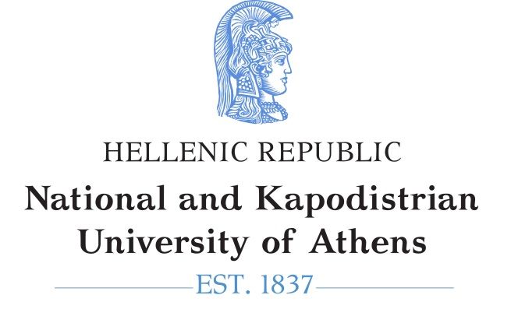 | 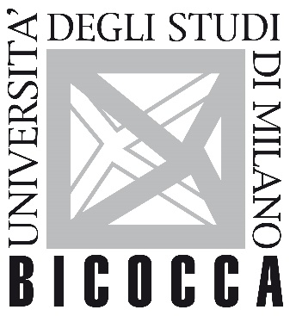

School of Medicine of National and Kapodistrian University of Athens
School of Medicine and Surgery (Dipartimento di Medicina e Chirurgia) of University of Milano−Bicocca

Postgraduate Cooperation Programme

"Endovascular Techniques"

Date: ……………

APPLICATION FORM

To
PCP Secretariat
First Name: | ……………………………………………………………………………..
Last Name: | ……………………………………………………………………………..
Father’s Name: | ……………………………………………………………………………..
Mother’s Name: | ……………………………………………………………………………..
Home address & phone no.: | ……………………………………………………………………………..
Work address & phone no.: | ……………………………………………………………………………..

Please enrol me as a postgraduate student in the Postgraduate Cooperation Programme on Endovascular Techniques.

Fill in the following:

- Department that awarded the Main Degree, Year and Grade (in numbers):

……………………………………………………………………………………………
- Department that awarded the MSc (if applicable):

……………………………………………………………………………………………
- Degree or Certificate in English-language competence

………………………………………………………………………………………………

I hereby submit the following supporting documents:

- Application Form
- Curriculum Vitae
- Copy of degree or certificate of completion of studies
- Academic transcript of undergraduate studies
- Publications in peer-reviewed journals, if applicable
- Proof of professional or research activities, if applicable
- Photocopy of ID card, front and back
- Two letters of recommendation
- Certificate of language proficiency for English, B2 level

Students from institutes abroad must submit the recognition certificate, or the ref. no. of the application submitted to Hellenic NARIC for recognition of their degree, in accordance with Article 34(7) of Law 4485/17.

The successful candidates will be selected by the SC based on the following criteria:

- Degree grade, which counts for 20%
- Grade average of three undergraduate courses relevant to the object of the PCP, which counts for 10%
- Research activity, which counts for 10%
- Publications, which count for 20%
- Letters of recommendation, which count for 10%
- Oral interview, which counts for 30%

The applicant

Further information is available on the programme website: www.grammateia.med.uoa.gr

